**Md Rajib Rari**

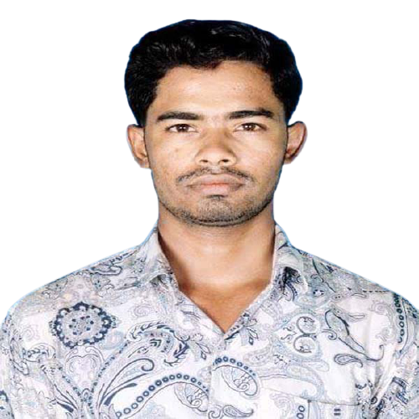

**Contact:** +8801571365449.

**Email:** [rajibhossen688@gmail.com](mailto:rajibhossen688@gmail.com)

**Git:** <https://github.com/rajib688>

**LinkedIn:** <https://www.linkedin.com/in/rajibrari>

**Portfolio:** <https://rajibrari.netlify.app>

**Address:** Purbo Bondo Dakpara, Zinzira, Keraniganj-1310,

Dhaka, Bangladesh.

**OBJECTIVE**

I’m a full-stack web developer with **2+ years of experience**. I have a passion for learning new techniques and sharing my knowledge with others as possible. I love to solve real-world problems. I will be obliged to dedicate my skills and fully utilize my activities for the sake of my software organization’s growth and development.

**PROFESSIONAL** **SKILLS**

* C#, ASP.NET Core MVC, .Net framework (N-Tire).
* Web API, Worker Service.
* Entity Framework, ADO.Net.
* LINQ, SQL Server Operation, Store Procedure, Data Table and Ajax.
* Front-end Design (HTML, CSS, Bootstrap & JavaScript).
* Operating System (Ubuntu (Linux), Windows7, Windows10).
* Database Backup-Restore.
* Unit of Work pattern, Repository pattern.
* Design Pattern & Principles, OOP.
* Dependency Injection, Autofac, Auto Mapper.
* Unit Test.

**WORKING EXPERIENCE**

**Jr. Software Engineer** at **Azolution Software & Engineers Ltd.**

Full stack web developer.

2023 June 01 – Continuing…

**PROJECTS**

* School Management System (N-tire)
* Blood Bank (MVC Database First)
* Personal Portfolio
* Attendance System (Console Base C#)

**EDUCATION**

|  |  |
| --- | --- |
| **Bachelor of Science in Computer Science and Engineering (B.Sc. in CSE).** | |
| University | Dhaka International University. |
| Session | 2016-2021. |
| Result | 3.51 Out of 4.00. |
| **Higher Secondary certificate (H.S.C).** | |
| Institute | Dr. Yakub Sharif College. |
| Board | Barisal. |
| Group | Science. |
| Session | 2015-2016. |
| Result | GPA 3.92 Out of 5.00. |
| **Secondary School certificate (S.S.C).** | |
| Institute | Bamnikati K.C.K Secondary School |
| Board | Barisal. |
| Group | Science. |
| Session | 2013-2014 |
| Result | GPA 4.06 Out of 5.00. |
| **Advanced English language Course.** | |
| Institute | Dhaka International University |
| Result | GPA 3.50 Out of 4.00. |

**TRAINING**

|  |  |
| --- | --- |
| **C#** | |
| Institute | Dev Skill. |
| **Web Application Development- Dot Net.** | |
| Institute | BASIS, SEIP. |
| **Business Excel.** | |
| Institute | BASIS & Pondit. |

**LANGUAGES** **PROFICIENCY**

Speaking & Writing proficiency in both Bangla & English language.

**PERSONAL DETAILS**

|  |  |
| --- | --- |
| Father’s Name | Md Abul Rari. |
| Mather’s Name | Mosa Amena Begum. |
| Permanent Address | Vill: Chabua, P.O: Basarabad, P.S: Bauphal, Dist. Patuakhali. |
| Sex | Male |
| D.O.B | 31-12-1999. |
| Nationality | Bangladeshi. |
| Height | “5.5”. |
| Weight | 66 kg. |
| NID NO | 2854812548. |
| Blood Group | A+. |
| Religion | Muslim (Sunni). |
| Marital status | Un-married. |
| Interest | Traveling, Listing Music, Playing (Cricket), Browsing. |

**REFERENCE**

Md. Abdullah Al Mamun.

Trainer: DOT NET, BASIS, SEIP.

BDBL Bhaban, Kawran Bazar, Dhaka- 1215.

Phone No: 01718 742 594.

Email: mabdullah.developer@gmail.com.

Relative: Teacher.

Khandakar Mohammad Mohi Uddin.

Assistant Professor, Department of CSE.

Dhaka International University (DIU).

Phone No: 01520-102813.

Email: mohiuddin.cse@diu.ac

Relative: Teacher.